- Hannah and Adam experienced increases in their incomes, and, consequently, their demand for burger decrease. When the price of burger increased, Hannah’s quantity demanded of burger decreased whereas Adam’s quantity demanded of burger increased.

- Using an appropriate model with diagram, explain Hanna’s demand for burger.
Price
Demand
Price
As the price of the burger increases, quantity for burger demanded by Hannah decrease and vice versa. This simply means that Hanna buys more burger when the price is low and buys less/fewer burger when the price of the same increases.

- Using an appropriate model with diagram, explain Adam’s demand for burger.
Price
Demand
As indicated above, when the price for burger increases, Adam’s demand for the same increases and vice versa. This means that more it costs the more Adam purchases. This is an example of prestige goods.

- Marina experienced a reduction in her weekly wage rate. Consequently, she decided to reduce her weekly working hours. Assume that there are only 80 weekly hours available to be allocated between work and leisure. Draw a diagram to show Marina’s original and new optimal points and the impact on her welfare. Explain your answer and diagram in detail

- Draw a diagram to show Marina’s original and new optimal points and the impact on her welfare. Explain your answer and diagram in detail.
Hours of work w1 s

W2

Q L Quantity of labour
Equilibrium price is where demand and supply are equal (1). There are no surpluses or shortages/no pressure for price to change

- Replicate the previously drawn diagram by hand

Draw by hand

- Chris is a borrower who faced an increase in interest rate.
- Draw a diagram to show the optimal choice for Chris. Explain your answer and your diagram in detail
interest 2

L1 L2 interest 1
Chris has to choose which loan to go for. Based on the interest rates, he will go for the loan that is cheaper to repay.
- Replicate the previously shown choice for Chris on a separate diagram. Then, split this decision into substitution and income effects. Explain your answer and your diagram in detail.

loan 1

new interest rates

B3
B1 X
B2 Y Initial loan interest

A1 A2 A3 Loan 2
Substitution effect results in a change in consumption from point X to point Y. The choice for loan A increases from A1 to A2, and the possible choice of loan B decreases from B1 to B2. Points X and Y give Chris the same level of utility as they lie on the same indifference curve.
- Use a simple model of exchange to show the conditions necessary for an efficient allocation of tow goods between two individuals. Use this model to evaluate the statement: “if two individuals have identical endowments of both goods there are no possible gains from trade”
Here, I will use the example of Gilligan and Marry Ann where the allocated goods are bananas and coconuts

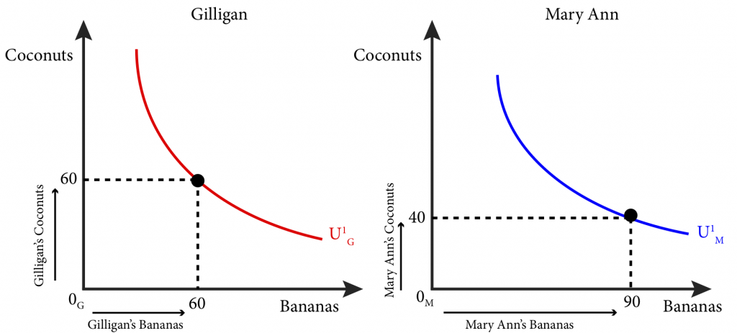

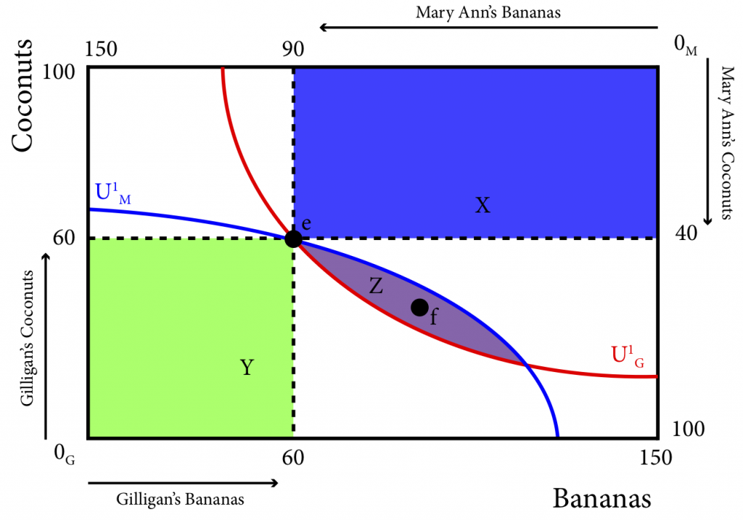
- Assume that Airbus (A) and boing (B) act as Cournot duopolists in the aircraft industry which has very high barriers of entry. The firms behave strategically by choosing output levels, produce a homogenous product, and have constant marginal cost, A’s marginal cost is $10 and B’s marginal cost is $20. Fixed cost is zero. The industry demand is Q=390-P

- Find the Cournot-Nash equilibrium output levels for each of the two firms and the market rice and total output; show all your working/calculations

Q = 390 – P
Output for A = 390 – 10 = 380
Output for B – 390 -20 = 370
Prices 380/10 = 38 for A
370/20 = 18.5 for B
Total out 380+370 = 750

- Draw a diagram showing the two reaction functions and the Cournot-Nash equilibrium point

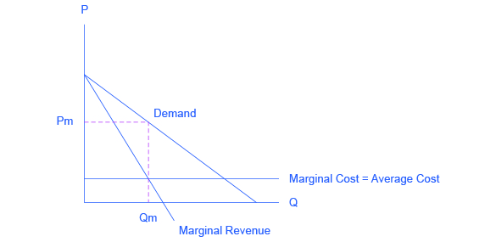
The above graph shows the market demand, marginal cost, and marginal revenue curve for firms in an oligopolistic industry at zero fixed costs.
Changes occur with change in price along the curve

